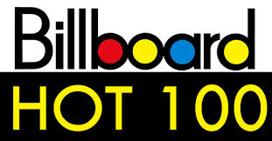

Team Members: Nader Elkhatib, Michal Harvanek, Todd Grubbs, David Liska and Beau Nguyen

| SMUDAL20190528DATA | Oct 8-2019

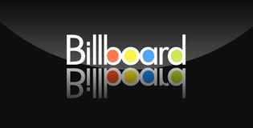

**Billboard’s Hot 100 Music (1960 to 2018)**

Introduction:

Music has been around for a long time and is create by different cultures. In America, there are so many different kinds of music that we listen to daily. Today, we are analyzing Billboard’s Music from 1960 to 2018.

Billboard Hot 100 is today’s music industry standard record chart in the United States for weekly and end of the year ranking songs. How the song is rank is by: sales (physical & digital), radio play and online streaming in the US.

The purpose of this project is to analyze how music has changes over the past years. Music fans are very curious to see if their favorite artists or songs made the list. Therefore, we have a couple of discoveries that viewers are very anxious to see.

Discoveries:

1. Which artist has the most Top 100 Hits?
2. Who has the most number of hits in 2018?
3. What year is the most obscene words use?
4. Which artist use the most obscene word per song?
5. Which artist has the most average word per song?

**Project 2 data process steps:**

1. Create GitHub repo: <https://github.com/nelkha2/Project2->
2. Finding data
   1. [pull](https://www.kaggle.com/rakannimer/billboard-lyrics) from Billboard Wikipedia
   2. pull from Lyrics from Genius APIs
3. Run Jupyter notebook
   1. Cleaning data about
   2. 5900 data records
   3. Columns: rank, artist, song, year, lyrics, decades & word counts
   4. Test data
   5. Merge data
4. Create PostgreSQL database
   1. Import data into PostgreSQL database
5. Build CSS
6. Build HTML
7. Build Python Flask
8. Load/Combine
9. Data visualization
   1. Webpage
   2. Chart/graph

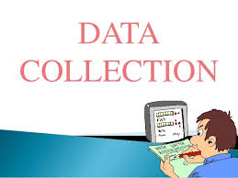

Fun Facts:

**Top 5 Artist with the most total word count:**

1. Rhianna 12,466
2. Eminem 11890
3. Madonna 11737
4. Usher 10495
5. Drake 10394

**Top Decade with the most total word counts together:**

1. 2000’s decade 400,958
2. 2010’s decade 375,607
3. 1990’s decade 374,219
4. 1980’s decade 279,168
5. 1970’s decade 241,700
6. 1960’s decade 195,341

**Top 5 Songs in 2018:**

1. Drake ‘God’s Plan’
2. Ed Sheeran ‘Perfect’
3. Bebe Rexha ‘Meant to Be’
4. Camilla Cabello ‘Havana’
5. Post Malone ‘Rockstar’

**Top 5 Taylor Swift songs:**

1. ‘Love Story’
2. ‘Blank Space’
3. ‘You Belong to Me’
4. ‘Shake It Off’
5. ‘I Knew You Were Trouble’